**COMPONENT COMPARISON**

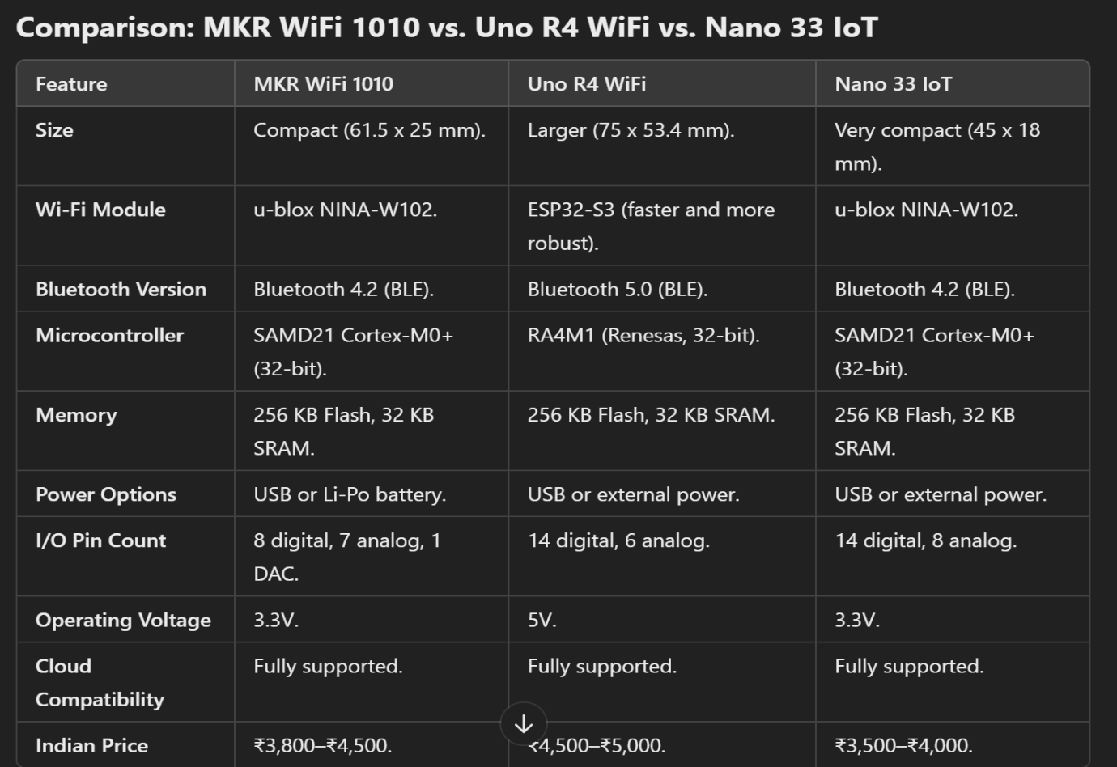

**All these 3 boards supports Arduino iot cloud and has built-in wifi modules**

1. **ARDUINO NANO 33 IOT**

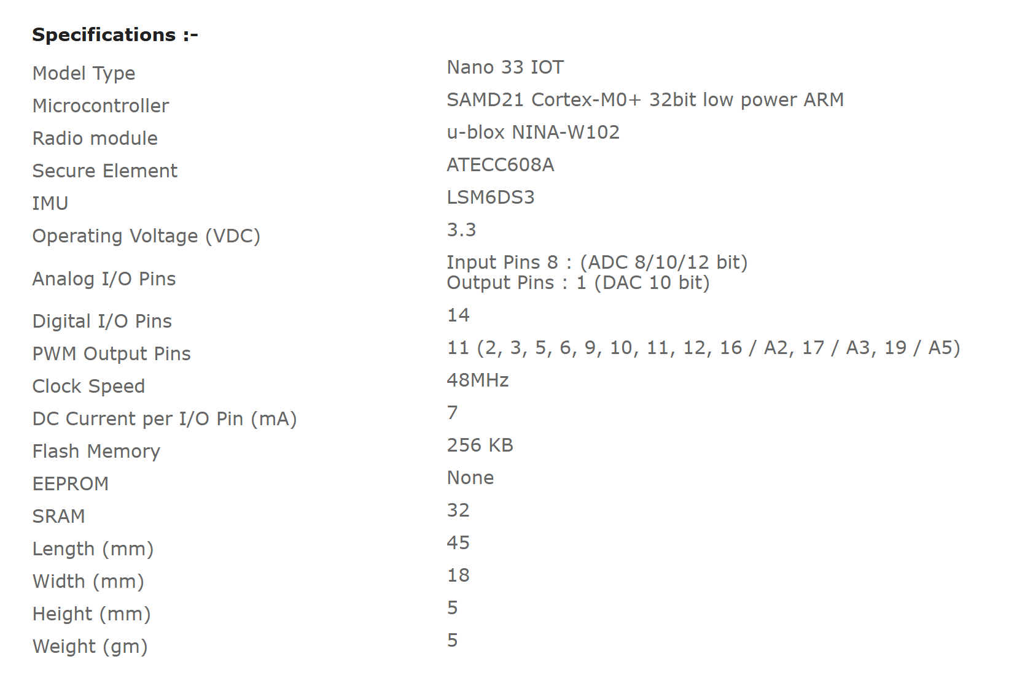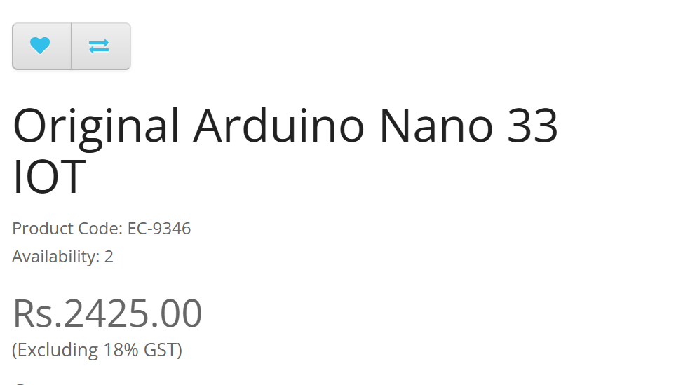

1. **Arduino MKR WiFi 1010**

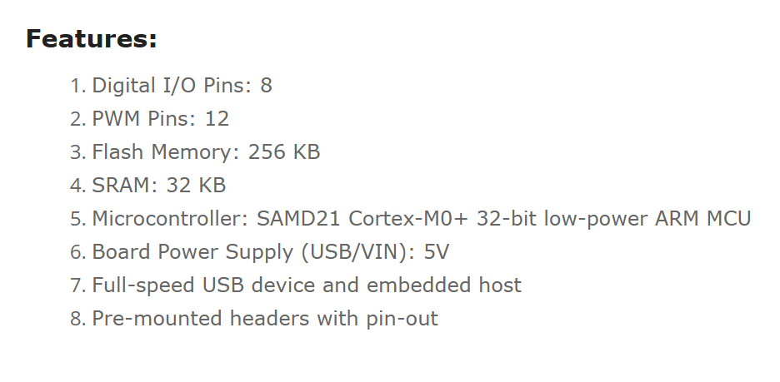

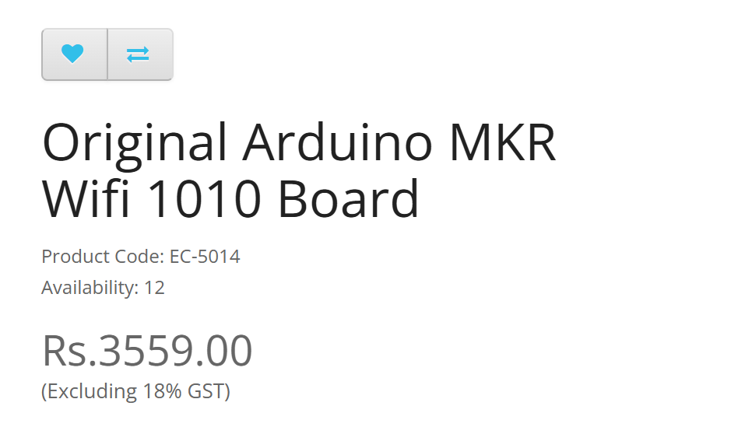

1. **Arduino Uno R4 WiFi** 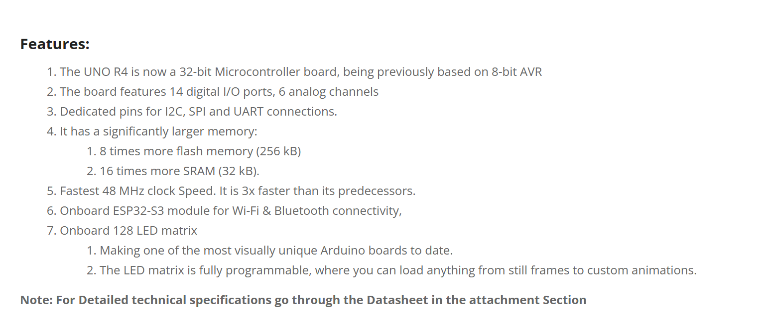

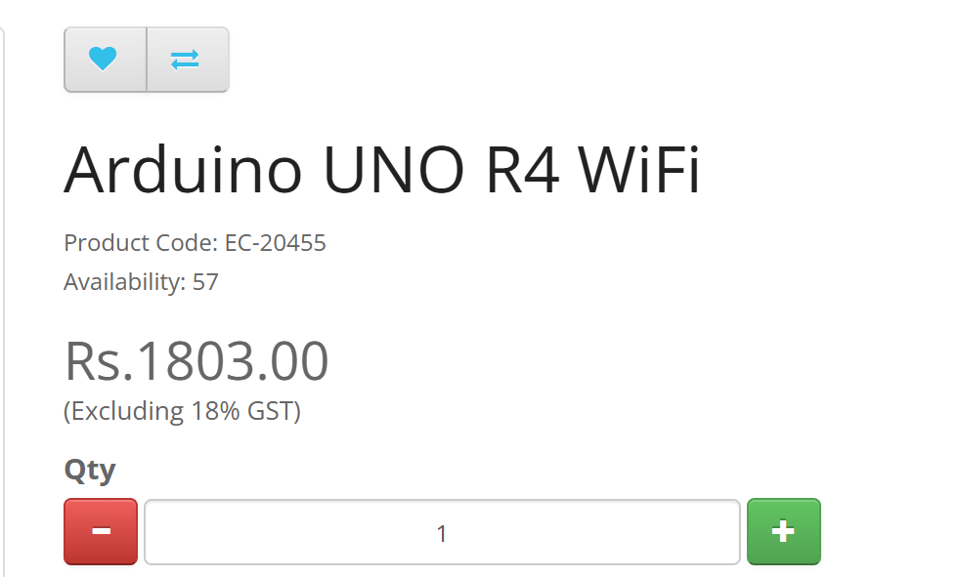

1. 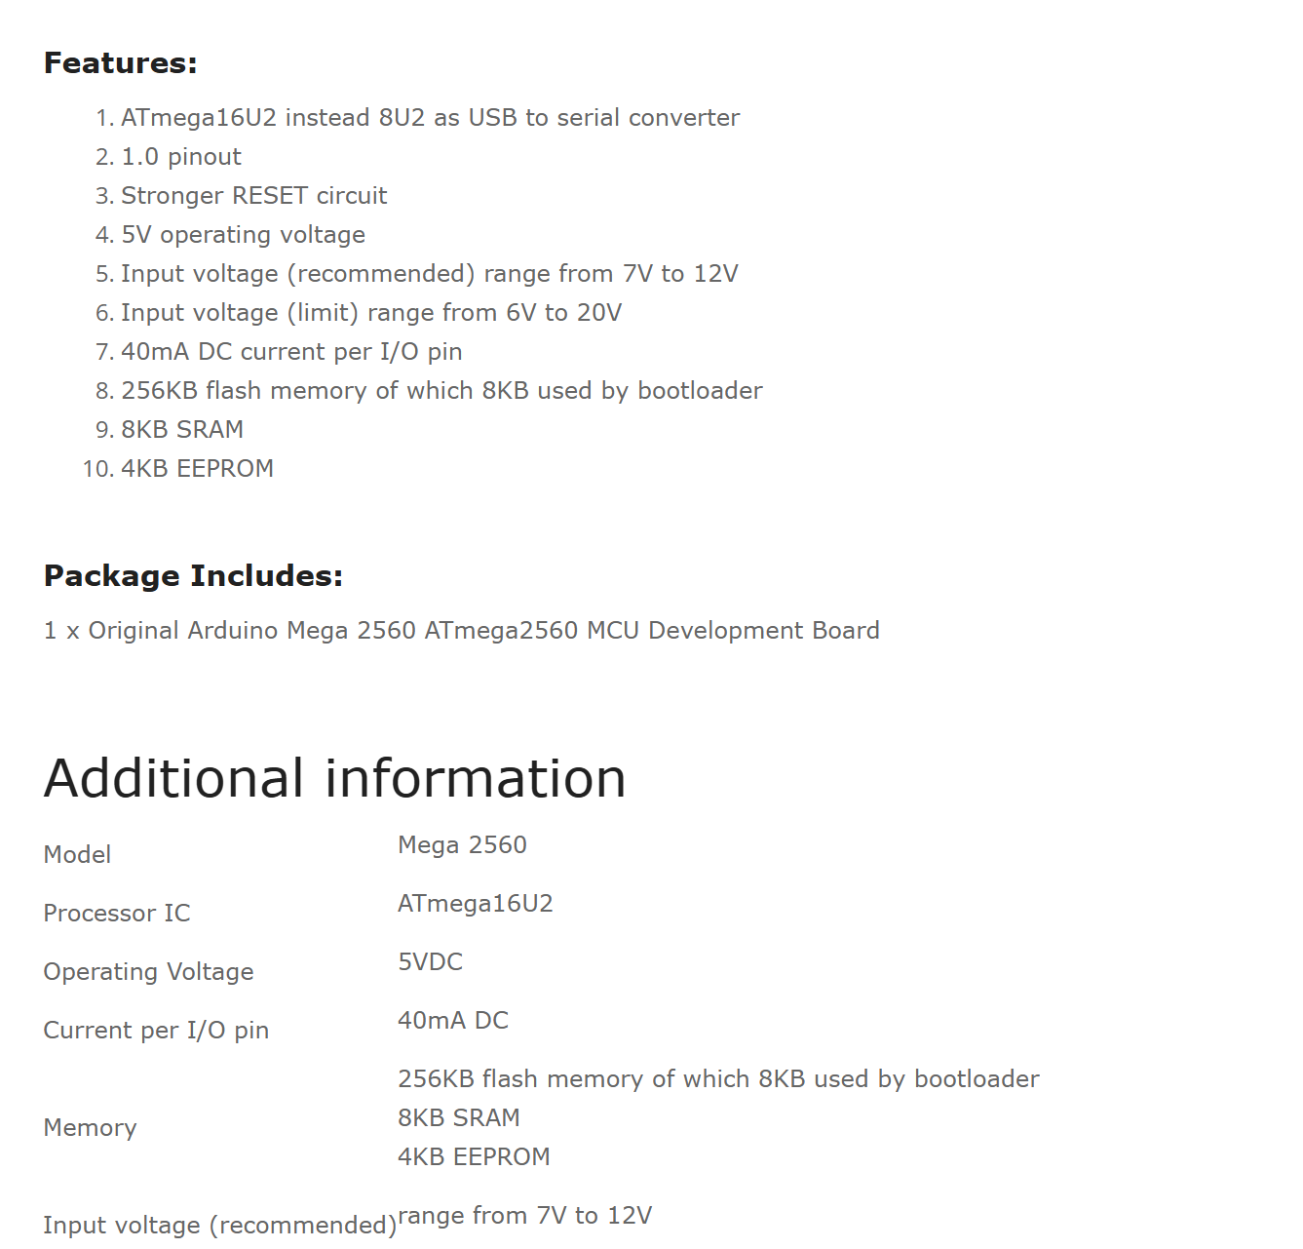**Arduino Mega 2560 Rev3.**

